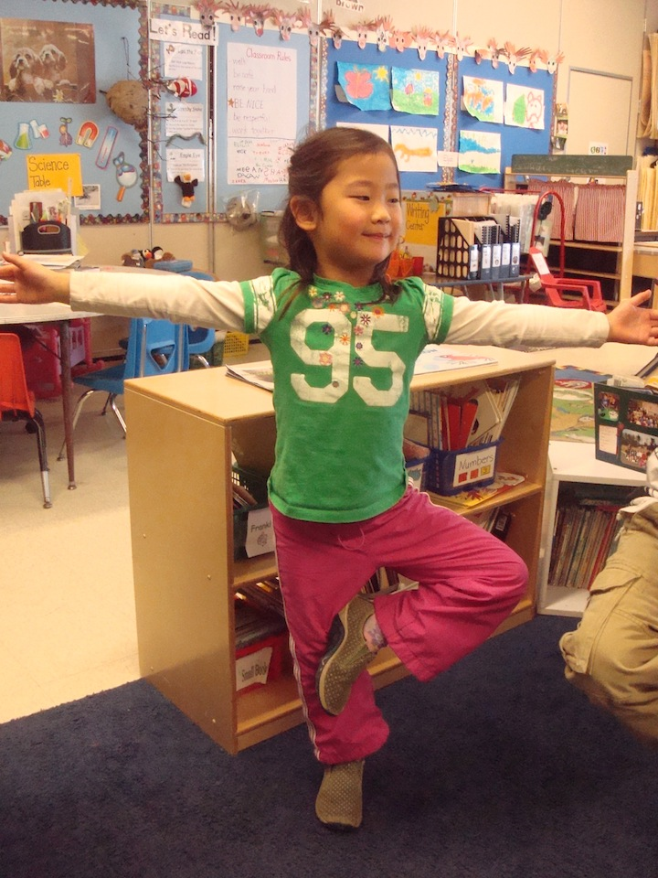

Dolor

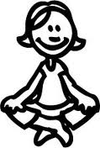

Healthy Kids Yoga and Nature Camp

Children Ages 4.5-7

$165 9:00-12:00

July 11th – July 15th

The Children’s Garden in Portsmouth

[290 Peverly Hill Rd, Portsmouth, NH 03801](http://www.bing.com/maps/default.aspx?cp=43.05457%7E-70.77983&where1=Children%27s%20Garden%20School&ss=ypid.YN570x9700548&FORM=SNAPST)

Space is limited!

Meet your Lead Instructor

**Janine Bibeau**

Kindergarten Teacher, Adult and Children’s Yoga Teacher and lover of plants and animals!

<http://yoga4healthwithjanine.weebly.com/>

Begin the morning with a 45-minute yoga class, which will involve the mind, body and breath. We will use music, props, and other creative movements to stretch, strengthen, and balance our bodies. We will breathe away tension, learn self-calming techniques, and build self-confidence too! Children’s yoga is engaging, playful, and fun!

The rest of our day will include nature and self-discovery. We will tap into our creative side and make nature crafts and play games that foster self- awareness and cooperation. We will use literature and tons of hands on experience to create the most fulfilling experience for your child. Through nature discovery, games and children’s yoga, we will connect to our roots, the Earth, and each other.

Our world is a wondrous place. Let us provide your child with a summer camp experience that they will cherish for a lifetime.

To register email [j9beck@hotmail.com](mailto:j9beck@hotmail.com) or call 603.817.8380

Yoga Camp!

Yoga 4 Health with Janine